Natural Language Processing

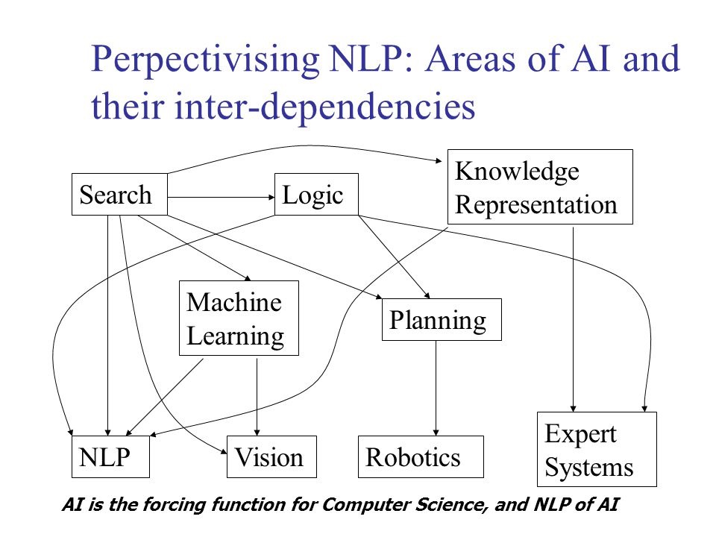
Unit 1: Intro to Natural Language Processing
Agenda:
- The study of Language
  - Language is on the fundamental aspects of human behaviour
  - It is a crucial component of our lives.
  - It could be written or spoken form:
    - Written form would serve as long term record for knowledge from one generation to the next
    - Spoken form serves as our primary means and coordinating our day to day behaviour with other.

2. Goals of NLP Research
  - Create computational models of language.
  - Able to specify models that approach human performance in the linguistic tasks.
    - Linguistic tasks are: reading, writing, hearing and speaking
  - Computational model are useful for scientific and practical purposes
    - scientific purpose - nature of linguistic communication
    - practical purpose - enabling effective human machine interaction

3. Different academic disciplines
  - Linguist - structure of the language
  - Philosopher - how words mean anything at all and not
  - Psycholinguists - process of human language production and comprehension
  - Computational Linguists - computational theory of language

Applications of Natural Language Processing
  - Text based application
  - Dialogue based application

Text based applications
  - Processing of written text - books, newspapers, reports, manuals, email messages and so on.
  - Finding appropriate documents on certain topics from database of texts
  - Extracting information from messages or articles on certain topics
  - Translating documents from one language to another
  - Summarising texts for certain purposes.
  - All may not use NLP, articles can be retrieved by simple matching technique.
  - Machine translation systems built on pattern matching - fails as it is unable to use an understanding of content to disambiguate word senses and sentence meanings.
  - Instead, produce a representation of meaning CONTD

